W-03

**YEAR 11 PHYSICS**

**TEST 3: NEWTON'S LAWS, WORK AND POWER**

**NAME: Total: **

1. A person's car battery has run flat. In an attempt to "jump start" the car, another person tries to push it

along a level driveway while the driver tries to start it.

(a) Why is it so hard or difficult to start the car moving?

(2)

(b) It becomes easier to move the car once it is rolling. Why is this?

(2)

2. A charged drop of oil (mass = 3.30 x 10-3 g) is moving at a velocity of 12.0 ms-1 in an experimental

chamber. It then experiences a retarding force for 2.00 ms, causing it to move at 2.00 ms-1 in the

opposite direction.

(a) Calculate the change in velocity of the oil drop.

(2) (b) Determine the force that acted during this short time.

(3)

(c) What impulse acted on the oil drop?

(2)

3. During the early Apollo space flights, a three-stage Saturn V rocket was used to lift the capsule into

space. During the separation of the 3.00 x 102 kg capsule from the 1.10 x 104 kg third stage, a small

explosive charge is used. At this point, the capsule and third stage are moving at 2.20 x 103 ms-1.

After separation, the capsule moves forward at 3.40 x 103 ms-1.

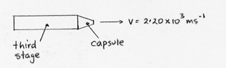

Calculate the final velocity of the third stage just after separation.

(4)4. A person of mass 90.0 kg is standing in a lift in an office tower. Calculate his apparent weight when:

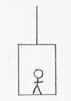 (a) the lift is moving upwards at a constant velocity.

(3)

(b) the lift is decelerating to a stop at 1.70 ms-2 when it nears the 20th floor of the building, having

risen up from the ground floor.

(4)

5. A roller coaster of total mass 8.73 x 103 kg is pulled by a mechanical track up to the top part of the

track as shown below. It takes 22.0 seconds to reach the top.

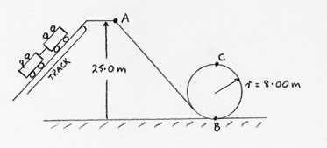

(a) Calculate the work done by the motor in shifting the roller coaster to the height at point A.

(3)

(b) What is the average power of the motor?

(2)

(c) At point A, the roller coaster has a speed of 4.00 ms-1. Calculate the total energy of the roller

coaster.

(3) (d) How fast would the roller coaster travel at point B?

(3)

(e) Would the roller coaster reach the speed you calculated in part (d)? Explain your answer.

(2)

TOTAL: 36 MARKS